Card-Based Memory Game

Documentation

Team#4–Java Tigers

Casey De Lorme

Rohan Ganpatye

Ryan Rubinstein

Piyush Dwivedi

Date: 25-May-2012

Revision: 1.0

**Table of Contents**

Executive overview 4

Audience 4

Assumptions made for this project 4

*Gantt chart* 5

Gantt task descriptions: 5

*Class and method overview* 6

Project UML 7

Client GUI 7

Protocols 8

Data used 9

Punch List used 10

To do: 10

Done: 10

Unresolved Issues 11

Revision History

|  |  |  |  |
| --- | --- | --- | --- |
| **Name** | **Date** | **Reason for Change** | **Version** |
| Piyush Dwivedi | 22-Apr-12 | Initial release | 0.1 |
| Rohan Ganpatye | 24-May-12 | Final Release | 1.0 |

Bit Bucket Revision History:

| **Author** | **Revision** | **Comments** | **Message** | **Labels** | **Date** |
| --- | --- | --- | --- | --- | --- |
| [[https://secure.gravatar.com/avatar/d20ac0bda5191cd6f2a874627045047e?d=identicon&s=16](https://bitbucket.org/CDeLorme)CDeLorme](https://bitbucket.org/CDeLorme) | [10eb0f493dab](https://bitbucket.org/CDeLorme/java3project2/changeset/10eb0f493dab) |  | Forgot to add the new menu items to the menu! |  | 8 days ago |
| [[https://secure.gravatar.com/avatar/d20ac0bda5191cd6f2a874627045047e?d=identicon&s=16](https://bitbucket.org/CDeLorme)CDeLorme](https://bitbucket.org/CDeLorme) | [2dd0f0f60429](https://bitbucket.org/CDeLorme/java3project2/changeset/2dd0f0f60429) |  | Integrated Private Chat with modifications to Client ChatGUI.java and Server ChatSystem.java. While functional, no message of the PM displays to the user who sent it, an update will be added later as I ran out of time to get this finished for the presentation. |  | 8 days ago |
| [[https://secure.gravatar.com/avatar/d20ac0bda5191cd6f2a874627045047e?d=identicon&s=16](https://bitbucket.org/CDeLorme)CDeLorme](https://bitbucket.org/CDeLorme) | [d4689461ce5d](https://bitbucket.org/CDeLorme/java3project2/changeset/d4689461ce5d) |  | Integrated a sleep process into the UPDATE GameSystem interpreter, such that the tiles remain displayed for two seconds before being removed and the score updating. |  | 8 days ago |
| [[https://secure.gravatar.com/avatar/d20ac0bda5191cd6f2a874627045047e?d=identicon&s=16](https://bitbucket.org/CDeLorme)CDeLorme](https://bitbucket.org/CDeLorme) | [f5dc822b0b53](https://bitbucket.org/CDeLorme/java3project2/changeset/f5dc822b0b53) |  | Updated the bash and batch scripts to generate JavaDocs pre-compile to a javadocs/ directory, which is next included with the jar file. |  | 8 days ago |
| [[https://secure.gravatar.com/avatar/d20ac0bda5191cd6f2a874627045047e?d=identicon&s=16](https://bitbucket.org/CDeLorme)CDeLorme](https://bitbucket.org/CDeLorme) | [0b21093b2549](https://bitbucket.org/CDeLorme/java3project2/changeset/0b21093b2549) |  | Updated "About" message dialog information. Added Instruction Menu, and Menu Items for Chat & Game instructions. |  | 8 days ago |
| [[https://secure.gravatar.com/avatar/d20ac0bda5191cd6f2a874627045047e?d=identicon&s=16](https://bitbucket.org/CDeLorme)CDeLorme](https://bitbucket.org/CDeLorme) | [49870f2333bc](https://bitbucket.org/CDeLorme/java3project2/changeset/49870f2333bc) |  | Updated Manifest File Information, and updated the bash and batch scripts. |  | 8 days ago |
| [[https://secure.gravatar.com/avatar/d20ac0bda5191cd6f2a874627045047e?d=identicon&s=16](https://bitbucket.org/CDeLorme)CDeLorme](https://bitbucket.org/CDeLorme) | [0a992b99718b](https://bitbucket.org/CDeLorme/java3project2/changeset/0a992b99718b) |  | Fixed a bug where the kill command was only sending the same gameID instead of the fresh ID. Now all game instances are closed. |  | 11 days ago |
| [[https://secure.gravatar.com/avatar/d20ac0bda5191cd6f2a874627045047e?d=identicon&s=16](https://bitbucket.org/CDeLorme)CDeLorme](https://bitbucket.org/CDeLorme) | [2735f0e22c96](https://bitbucket.org/CDeLorme/java3project2/changeset/2735f0e22c96) |  | Fixed buggy score counting "ending" of games server-side. Added a 2 second timeout after the second displayed icon that presents sending additional clicks, and hides all displayed icons after. I then removed the hack that allowed clicking already displayed icons. |  | 11 days ago |
| [[https://secure.gravatar.com/avatar/d20ac0bda5191cd6f2a874627045047e?d=identicon&s=16](https://bitbucket.org/CDeLorme)CDeLorme](https://bitbucket.org/CDeLorme) | [76db0dce9245](https://bitbucket.org/CDeLorme/java3project2/changeset/76db0dce9245) |  | Finally adding images, would help to see what you are clicking on, right? |  | 11 days ago |
| [[https://secure.gravatar.com/avatar/d20ac0bda5191cd6f2a874627045047e?d=identicon&s=16](https://bitbucket.org/CDeLorme)CDeLorme](https://bitbucket.org/CDeLorme) | [03bc54abc649](https://bitbucket.org/CDeLorme/java3project2/changeset/03bc54abc649) |  | Added three missing files from last push. |  | 11 days ago |
| [[https://secure.gravatar.com/avatar/d20ac0bda5191cd6f2a874627045047e?d=identicon&s=16](https://bitbucket.org/CDeLorme)CDeLorme](https://bitbucket.org/CDeLorme) | [d81fc0ea8343](https://bitbucket.org/CDeLorme/java3project2/changeset/d81fc0ea8343) |  | Given that we are using the icons from the old Super Mario Brothers game, I downsized to the matching 3 rows by 6 columns used originally. |  | 11 days ago |
| [[https://secure.gravatar.com/avatar/d20ac0bda5191cd6f2a874627045047e?d=identicon&s=16](https://bitbucket.org/CDeLorme)CDeLorme](https://bitbucket.org/CDeLorme) | [931aae67c15d](https://bitbucket.org/CDeLorme/java3project2/changeset/931aae67c15d) |  | Ran a diff comparison to see why the newest upload wasn't working, found missing changes in four files. |  | 12 days ago |
| [[https://secure.gravatar.com/avatar/d20ac0bda5191cd6f2a874627045047e?d=identicon&s=16](https://bitbucket.org/CDeLorme)CDeLorme](https://bitbucket.org/CDeLorme) | [05c4159025dc](https://bitbucket.org/CDeLorme/java3project2/changeset/05c4159025dc) |  | Confirmed foreign character support in Chat system, adjusted on-send to clear the input text field. Also, focus is set at startup to the input box. Completed the Challenge operation in the Chat GUI. |  | 12 days ago |
| [[https://secure.gravatar.com/avatar/d20ac0bda5191cd6f2a874627045047e?d=identicon&s=16](https://bitbucket.org/CDeLorme)CDeLorme](https://bitbucket.org/CDeLorme) | [211e52f9ed9e](https://bitbucket.org/CDeLorme/java3project2/changeset/211e52f9ed9e) |  | Used the Code Rohan had begun preparing and created JPanel extension Game Memory Display and Server Side Grid Button Display System. |  | 13 days ago |
| [[https://secure.gravatar.com/avatar/d20ac0bda5191cd6f2a874627045047e?d=identicon&s=16](https://bitbucket.org/CDeLorme)CDeLorme](https://bitbucket.org/CDeLorme) | [56ba16a2f991](https://bitbucket.org/CDeLorme/java3project2/changeset/56ba16a2f991) |  | Fixed a connection bug with multiple output messages and a failed call to getCM(). |  | 14 days ago |
| [[https://secure.gravatar.com/avatar/d20ac0bda5191cd6f2a874627045047e?d=identicon&s=16](https://bitbucket.org/CDeLorme)CDeLorme](https://bitbucket.org/CDeLorme) | [d4b0af840057](https://bitbucket.org/CDeLorme/java3project2/changeset/d4b0af840057) |  | Merged UserSystem with ChatSystem, I intend to do the same with MatchMakingSystem, since the purposes are very tied together. |  | 14 days ago |
| [[https://secure.gravatar.com/avatar/d20ac0bda5191cd6f2a874627045047e?d=identicon&s=16](https://bitbucket.org/CDeLorme)CDeLorme](https://bitbucket.org/CDeLorme) | [ba3f924a2887](https://bitbucket.org/CDeLorme/java3project2/changeset/ba3f924a2887) |  | Apparently I forgot the manifests for Server & Client too, I am just filled with git errors today. |  | 14 days ago |
| [[https://secure.gravatar.com/avatar/d20ac0bda5191cd6f2a874627045047e?d=identicon&s=16](https://bitbucket.org/CDeLorme)CDeLorme](https://bitbucket.org/CDeLorme) | [a4ea28e6f2b2](https://bitbucket.org/CDeLorme/java3project2/changeset/a4ea28e6f2b2) |  | Missed a file, compiling bugs abundant, sorry bout' that. |  | 14 days ago |
| [[https://secure.gravatar.com/avatar/d20ac0bda5191cd6f2a874627045047e?d=identicon&s=16](https://bitbucket.org/CDeLorme)CDeLorme](https://bitbucket.org/CDeLorme) | [e688d9e05db5](https://bitbucket.org/CDeLorme/java3project2/changeset/e688d9e05db5) |  | Fixed a mnemonic bug in SystemGUI.java, Disconnect maps to "D" now. |  | 14 days ago |
| [[https://secure.gravatar.com/avatar/d20ac0bda5191cd6f2a874627045047e?d=identicon&s=16](https://bitbucket.org/CDeLorme)CDeLorme](https://bitbucket.org/CDeLorme) | [da6336ae0336](https://bitbucket.org/CDeLorme/java3project2/changeset/da6336ae0336) |  | Updated Server.sh file, Server now starts as its own process. Script will print process for kill command, and all output will be placed into a serverDebug.txt file instead of printed to the console. |  | 14 days ago |
| [[https://secure.gravatar.com/avatar/d20ac0bda5191cd6f2a874627045047e?d=identicon&s=16](https://bitbucket.org/CDeLorme)CDeLorme](https://bitbucket.org/CDeLorme) | [a76ed183c3ac](https://bitbucket.org/CDeLorme/java3project2/changeset/a76ed183c3ac) |  | Added bash and batch files to compile to jar and run both Client and Server components. |  | 14 days ago |
| [[https://secure.gravatar.com/avatar/d20ac0bda5191cd6f2a874627045047e?d=identicon&s=16](https://bitbucket.org/CDeLorme)CDeLorme](https://bitbucket.org/CDeLorme) | [02179297ccf3](https://bitbucket.org/CDeLorme/java3project2/changeset/02179297ccf3) |  | Attempting to fix bugs from previous compile, various changes have been made, more on the way. |  | 15 days ago |
| [[https://secure.gravatar.com/avatar/d20ac0bda5191cd6f2a874627045047e?d=identicon&s=16](https://bitbucket.org/CDeLorme)CDeLorme](https://bitbucket.org/CDeLorme) | [0c90650f1368](https://bitbucket.org/CDeLorme/java3project2/changeset/0c90650f1368) |  | Major changes to source code, you may want to wipe and clone fresh. |  | 20 days ago |
| [[https://secure.gravatar.com/avatar/d20ac0bda5191cd6f2a874627045047e?d=identicon&s=16](https://bitbucket.org/CDeLorme)CDeLorme](https://bitbucket.org/CDeLorme) | [de78f81f460a](https://bitbucket.org/CDeLorme/java3project2/changeset/de78f81f460a) |  | Modifications to the client system, integrated a login GUI with a 10 second timeout. |  | 28 days ago |
| [[https://secure.gravatar.com/avatar/d20ac0bda5191cd6f2a874627045047e?d=identicon&s=16](https://bitbucket.org/CDeLorme)CDeLorme](https://bitbucket.org/CDeLorme) | [e8bd68d8abe3](https://bitbucket.org/CDeLorme/java3project2/changeset/e8bd68d8abe3) |  | Added useful server output messages. |  | 29 days ago |
| [[https://secure.gravatar.com/avatar/d20ac0bda5191cd6f2a874627045047e?d=identicon&s=16](https://bitbucket.org/CDeLorme)CDeLorme](https://bitbucket.org/CDeLorme) | [a2a96e045027](https://bitbucket.org/CDeLorme/java3project2/changeset/a2a96e045027) |  | Removed Old File References |  | 2012-04-16 |
| [[https://secure.gravatar.com/avatar/d20ac0bda5191cd6f2a874627045047e?d=identicon&s=16](https://bitbucket.org/CDeLorme)CDeLorme](https://bitbucket.org/CDeLorme) | [183202262364](https://bitbucket.org/CDeLorme/java3project2/changeset/183202262364) |  | Added Visio Diagrams. |  | 2012-04-16 |
| [[https://secure.gravatar.com/avatar/d20ac0bda5191cd6f2a874627045047e?d=identicon&s=16](https://bitbucket.org/CDeLorme)CDeLorme](https://bitbucket.org/CDeLorme) | [f82f4482acea](https://bitbucket.org/CDeLorme/java3project2/changeset/f82f4482acea) |  | Initial Upload of Source Code. |  | 2012-04-16 |

# Executive overview

*This is a pretty simple card based memory game, which is played on a GUI (Graphical User Interface) created using JAVA.*

*The GUI has fifty two buttons acting as cards, which are two sets of twenty six alphabets that are identical to each other. The cards face do not show when you start the game. Every click on the buttons shows the face of the card and clicking on two identical cards gives the user one point. This goes on till all the cards have been clicked and in the end, the player with the most number of points is declared the winner.*

*The game also has the added feature of a chat client, where the players can chat with each other. The technicalities of the project are discussed in detail, later in this document.*

# Audience

*This documentation serves particularly useful for independent game developers, java programmers, free lancers in the coding industry, and/or anybody else who is particularly interested in a multiplayer game implementation over the network and understanding the importance of providing the user with a public & private implementation of an integrated chat system with the game.*

# Assumptions made for this project

*We made quite a few assumptions for this project. Some of them are listed below:*

1. *At least two players will play this game at any given point of time.*
2. *We planto use networking for this project, so that two players on two different machines can play this game without any hassles.*
3. *We will try and implement the game such that more than two players can play the game as well.*
4. *Everyone will love this game.*

# *Gantt chart*

A Gantt chart representing all the tasks assigned to each of the members of the team, the tasks that require collaborative work of 2 or more team members and the time required to successfully complete each of those tasks is presented through the MS Project Documentation file provided as a supplement to this documentation.

## Gantt task descriptions:

| **WBS** | **M** | **Tasks** | **Date (if known)** |
| --- | --- | --- | --- |
| 1 | M | Assigned project ideas | w3c2-d8 3/23/2012 |
| 2 |  | Individually think about possible projects |  |
| 3 | M | Project ideas discussed in class | w4c1-d10 3/28/2012 |
| 3.1 |  | Discuss projects with possible team(s) / team member(s) |  |
|  |  |  |  |
|  | M | Teams formed | w4c1-d11  3/28/2012 |
|  |  |  |  |
| N | M | Design Document assigned | w4c2-d12  4/4/2012 |
| N.1 |  | *Design discussions {incl: scope of project}* |  |
| N.2 |  | *Update design document* |  |
| N.3 |  | *Risk management plan* |  |
| N.4 |  | Alternate design solutions to overcome the risks uncovered during risk analysis |  |
|  |  | System Design |  |
|  | M | Team present project topic to class | w5c1-d13  4/9/2012 |
|  |  | *GUI Prototype* |  |
|  | M | Write project plan for lab, update design document | w5c3-d15  4/12/2012 |
|  |  |  |  |
|  | M | Design Documents due for review, end of class | w6c1-d16  4/16/2012 |
| N.1 |  | Incorporate the changes suggested in the design document during the review. |  |
|  |  |  |  |
|  |  |  |  |
|  | M | Mid-project review: GUI with integrated chat | w8c2-d23  4/30/2012 |
|  |  |  |  |
|  |  | Teams write test document – due in class | w9c3-d27  5/10/2012 |
|  |  |  |  |
|  |  | *System testing – update test document with results* |  |
|  | M | Grid testing *{tentative}* | w10c1-d28  5/14/2012 |
|  |  |  |  |
|  |  | Team by team review/evaluations with instructor | w10 d29-30  5/17/2012 |
|  |  |  |  |
|  |  | *Prepare presentation* |  |
|  | M | Trade show (System Deployment) | *Week 11*  *5/25/2012* |

*M = Milestones*

# *Class and method overview*

The following section presents an overview of the classes and functionality. Here we illustrate an exoskeleton of the code based primarily on the classes implemented and through their hierarchical dependencies.

Project parameter Interface

* Contains Port number constants, used by Client and Server
* Contains Author and About messages

Client

Connection

Interface -> Classes:

* Receiver
  + ClientCommandSystem
    - ClientInterpreter
    - ChatClientInterpreter
    - GameClientInterpreter
      * GameClient
        + MemoryClient

Server

Interface -> Classes:

* Commander
  + ServerCommandSystem
    - Interpreter
      * ChatServerInterpreter
      * DebugServerInterpreter
      * GameServerInterpreter
        + GameManager

GameFactory

Game

Memory

* + UserManager
    - UserFactory
      * User
        + ServerClient

# <Project> UML

See Attached PDF Diagrams(Provided as two separate files one each for the Client and the Server).

# Client GUI

The Client GUI can be described as a collaborative system of two major components.

The First one being the Client Game GUI that is presented to every userupon game instantiation and the Tile class for the Client that holds the information about all the game tiles presented on the GUI such as their name, the image held behind them and most importantly their location on the grid with respect to the x, y co-ordinates.

# Client GUI Screenshots:

Login

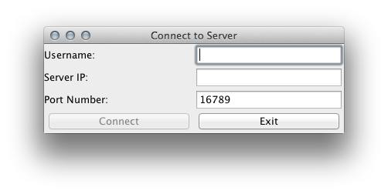

Connection to a real server (Connect available on entered data):

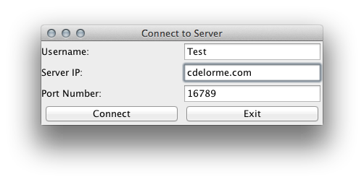

Chat Client

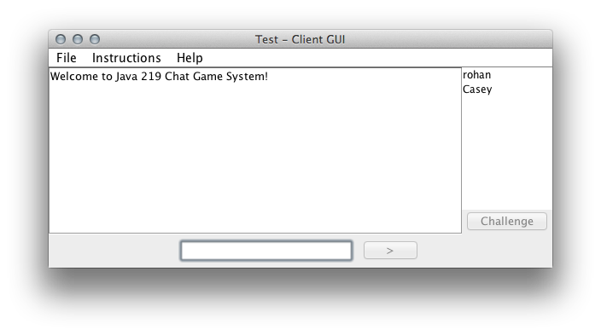

User Selected Enables Challenge

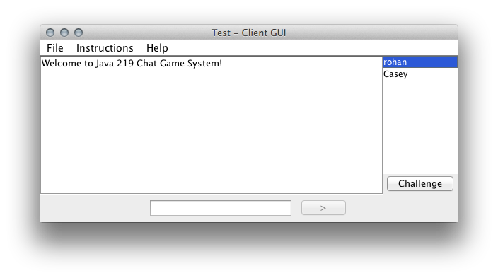

Challenge Based Game Initiation:

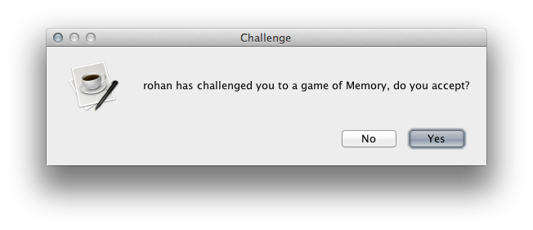

First turn goes to challenger, buttons disabled:

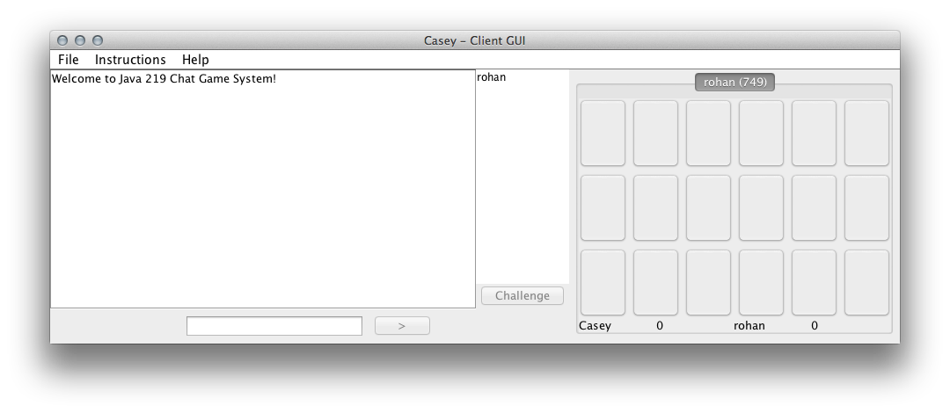

Buttons Active during user turn, tiles change on click using message from server:

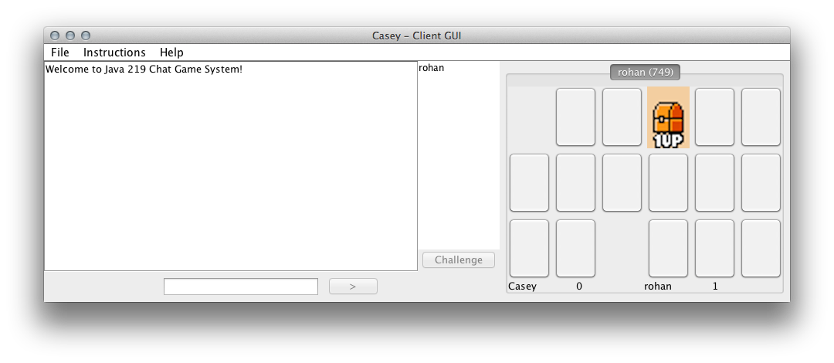

Protocols

IP Number will be dynamic depending on which machine the “Server” is run on, and the Client can specify the server (Possibly in the GUI).

Port number(s): 16789

Protocol interface code for both client and server:

*We are using a constant for the port number, as that is going to be same every time. We really do not have any special protocols or interfaces that we are using. It is just basic TCP/IP with server socket and socket classes.*

Communication class:

We are using basic CLI (command line interpreter) with hash tables and scalable interpreter interface.

**Chat interaction between Clients and Server.**

*Presented in class on 04/19/12.*

*When the user starts the game, he is presented with a dialog box to enter the port number and the connection address along with a username. If the Client establishes a connection to the game server, then the Game GUI is presented to the client. However, the Game is not instantiated at this moment.*

*The client is however provided with a list of all the users currently connected to the game server.*

*The Client can then select any active user and challenge the user to a game through the interface. If the user accepts the challenge, then a game instance is created with a random game ID and the game GUI is presented to each of the two users.*

*Both the users connected to the game can now chat during the game play and take turns to play the game. The player with his active turn to play has an active game panel on which he/she can make tile selections where as the other user has a non-interactive game panel until its his/her turn to play.*

*The chat system implemented is scalable to serve any number of active user interactions.*

*The chat system implemented for user interaction during the game play is now extended to also provide an additional functionality of providing the user an option of a private chat with any other user of his/her choice.*

*The private chat is implemented with a ‘@’ symbol as a prefix to the username at which the private message is directed at. The ‘@' gets interpreted by the interpreter module that understands that the following message is a private message for the username which follows after the ‘@’ character.*

| **Client** | **Communication** | **Server** |
| --- | --- | --- |
|  |  | Startup |
|  |  | Waits for client to connect  Accept connection |
| Client connection | Connection, no data 🡪 |
| Client sends username and connection information | Username name is sent over the network to the server for validation | Server reads info  Username conflicts are reported to the Client |
|  |  | If username does not exist client connection to the server is achieved |
| Client receives List of users connected to the server | 🡨 List of all the users connected to the server is sent to the newly connected client and a Client Game GUI is loaded | Connects client to the server.  Presents a Game GUI without a game instance and a list of all the users currently connected to the server. |
| Client can chat with any/all the users connected to the server in a public or private chat mode using a ‘@username’ format. |  |  |
| Client selects a user from the list of users connected and challenges a game | Challenge request sent over the network to the user chosen by the client for a game | Server receive the request and processes it to the appropriate user for a accept/decline response |
|  | 🡨Yes or No response sent over to the client | The server processes the response from the challenged client and sends it back to the user who challenged a game |
| If the response from the server is a Yes, a game is instantiated between the challenging client and the challenged client | Game/Chat interaction between the two clients connected through a common game instance |  |
|  |  |  |

# Data used

*The data used for building up the game includes a random collection & assignment of images that are to be displayed as a part of the memory matching game represented behind each of the game tile.*

*We added Super Mario Brothers images from their edition of the Memory game implemented in Super Mario Brothers 3 for Nintendo.*

# Punch List used

*Establish Client connection with the server after validation for username conflicts and valid server address and communication port number.*

*Populate the client GUI with a list of all the users connected to the server.*

*Establish chat connectivity and interaction on the Client GUI (Public Chat).*

*Establish chat connectivity and interaction on the Client GUI between any two users connected (Private Chat).*

*Provide the user with the ability to challenge any other user for a game.*

*Establish the possibility of any number of game instances to be created for a user with any other users.*

## *Forfeiting of a game instance by the user is handled properly by the server and does not cause server crash.*

Establish a turn-based game between any two playing users. Providing feedback indicating which user’s turn to play.

Score keeping for a match of tiles to determine at the end of the game, the winner for that game.

## *To do:*

*To solve the problem of client double click on the same tile to give a match in the game.*

*Bug introduced due to a 2 second aesthetic delay in the tiles to switch and be passed over to the network for processing a tile match based on the coordinates and image. Possible attributions to network latency. To fix modifications to server to record and compare coordinate clicks.*

## *Done:*

*Problem with communicationserver crashing – fixed on 4/1/11*

# Unresolved Issues

*Due to time constraints the following features and code changes could not be added, but were planned changes for future revisions:*

*UML Diagram Rebuild.*

*Bugfix, aesthetic change allows double-clicking of tiles.*

*The code is messier than I would have preferred due to the rush that occurred the final week when team members disappeared. To save time I abbreviated variable and method names, I would have liked to expand them all to meet proper naming convention standards.*

*I introduced an enormous flaw in the Client GUI layering the processing systems behind the GUI forcing the Command System to run deep into the GUI layers and creating various limitations and requiring Mediators to establish limited callback functionality. This would have taken several hours to fix, but given the time I would have liked to swap it to a Modular GUI system, generating all components at the start, and passing the display objects to the systems that would update them, instead of the reverse.*

*I could have reduced the number of passed dependencies by adding an interpret command inside the Client/Connection objects on both ends, allowing direct calls to be made through the Command system locally.*

*I was hoping to add a menu item to end a game pre-maturely, however I was unable to implement this command request.*

*Color code private messages? I don't know how I would do this so probably not a feature I will implement.*

*I was hoping to add a menu item that would allow users to select to end their games prematurely, but that never came to pass.*

*I had intended to create a Message System such that a message would open a JOptionPane from Server to Client without being tied to any other system. This would have helped for situations like declined challenges, and informing a user their opponent disconnected.*

*I had also wanted to integrate animation so changes in the GUI display were not as abrupt, but gradual. A simple threaded timer with a custom resize event would have been nice looking.*

*I also would have rather added a UserID system instead of just usernames, but this would have added a whole different level of complexity so I decided against it. However, it would have been much more versatile than username checks.*

*Finally, I really wanted to create some form of thread pooling for the server, such that not every single connection got its own thread, but a fixed number of threads shared responsibility for checking each connection for activity. Technically the sockets would not close, but one thread wouldn't be sitting waiting for an idle user, it could go check for other requests. I didn't have enough time to investigate this, let alone implement it.*